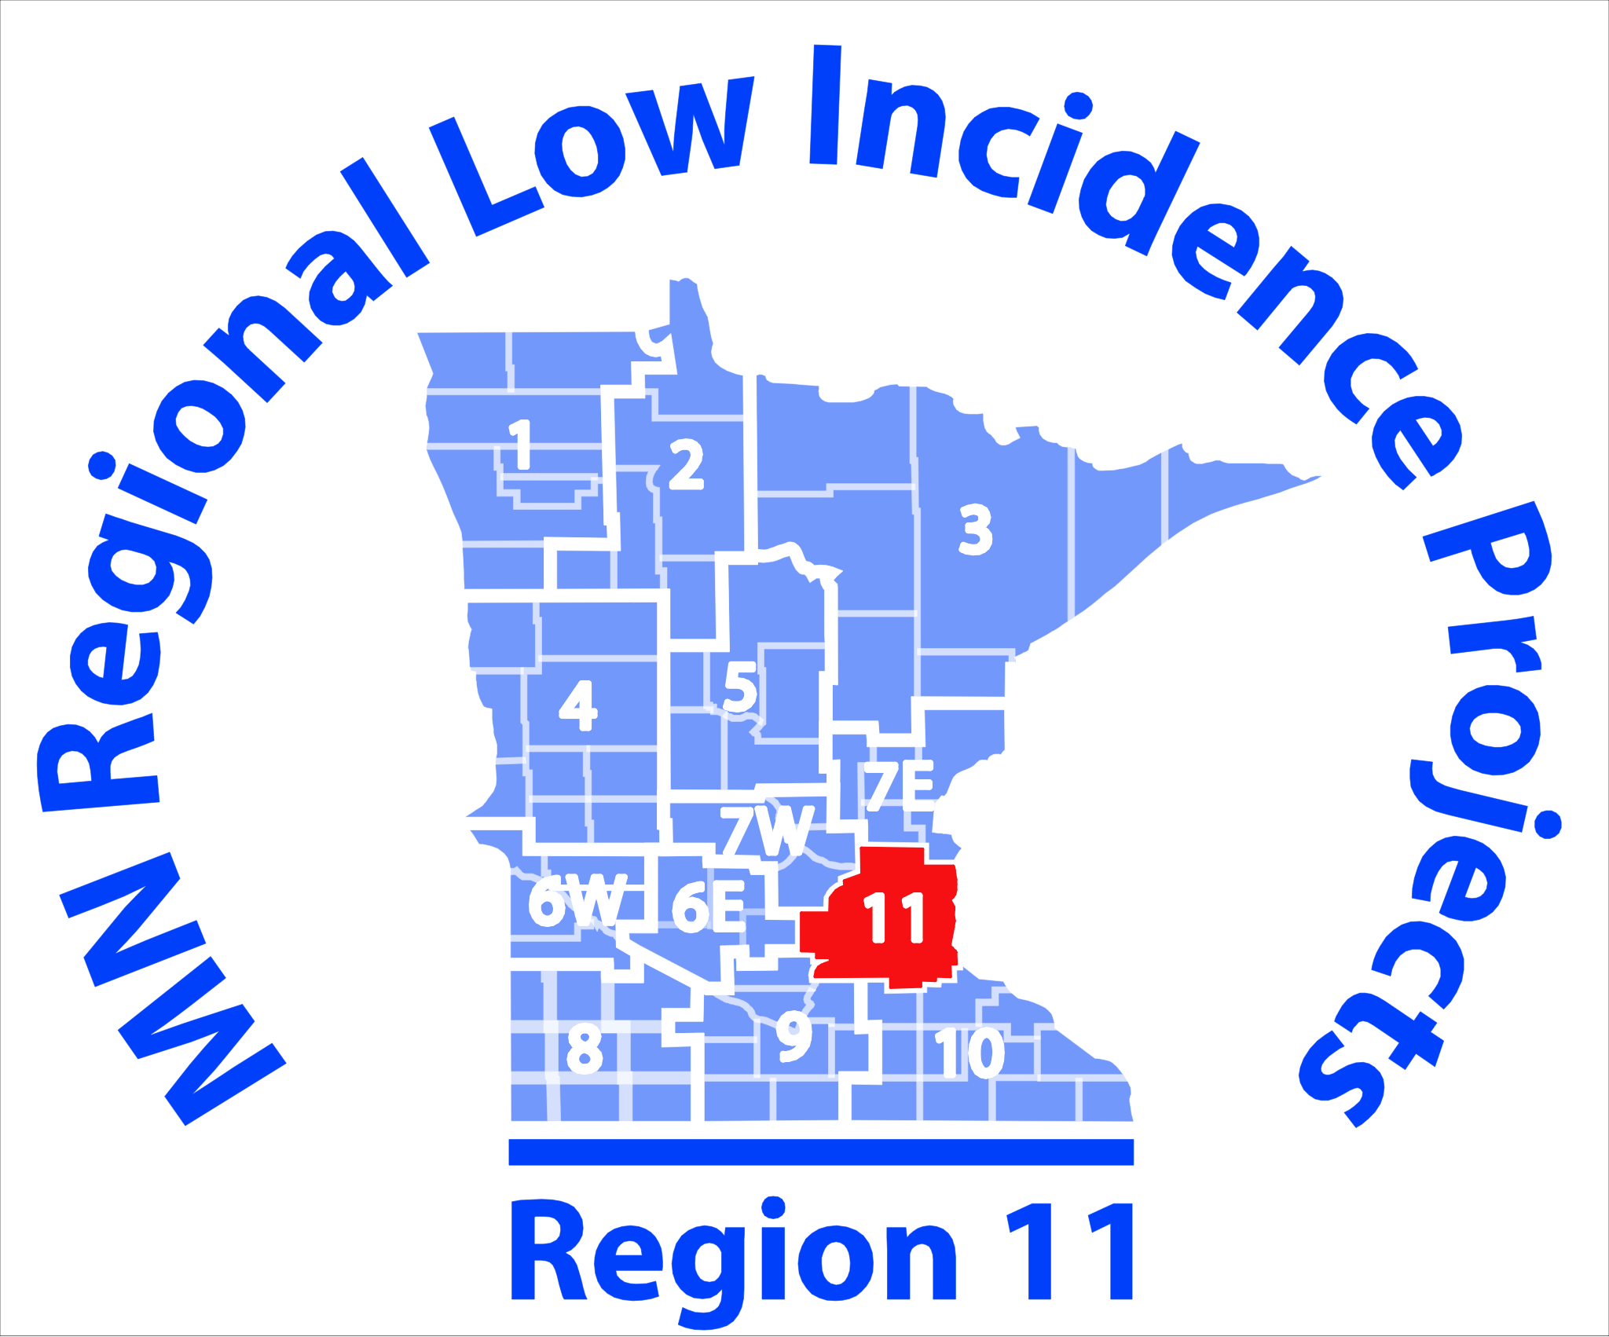
AT Community of Practice Agenda:

September 26, 2017
1:00-3:00 p.m.

Metro ECSU
Training Room
2 Pine Tree Drive
Arden Hills, MN 55112

TechTalk Committee meets at 11:00 am prior to AT Network Meeting

1. Introductions
2. Changes in our AT Network, and our Goals for the Year
3. SubAwards
4. Review of Information from AT Leadership Team meeting at MDE
5. Discussion on how to create Cross-Regional Calendar
6. Discussion on Cross-Regional Website
7. Planning for Future Meetings

Note Taker: TBD

This initiative is made possible in whole with a grant from the Minnesota Department of Education using federal funding, CFDA 84.027A, Special Education – Grants to States.

This event does not necessarily represent the policy of the federal Department of Education or the state Department of Education. You should not assume endorsement by the federal or state government.

